CONTENTS

TOPICS COVERED PAGE NO.

- INTRODUCTION……………………………………………02

- REQUIREMENTS………………………………………………………04

- INTRODUCTION TO C ++ ……………………………………………05

- DETAILED INTRODUCTION AND ANALYSIS………………….....07

- PROBLEM STATEMENTS…………………………………………….10

- DESIGN INCLUDING DATAFLOW DIAGRAM ………...…..12

- CODING…………………………………………………………………19

- TESTING INCLUDING SNAPSHOTS………………………………....36

- CONCLUSION……………………………………………………….....40

- ADVANTAGES AND DISADVANTAGES……………………………41

- FUTURE ENHANCEMENTS……………………………………….....42

- BIBLIOGRAPHY………………………………………………..……..43

INTRODUCTION

- TOPIC:

Extensible hashing is one of several hashing systems that allow the address space for hashing to grow and shrink along with the file. Because the size of the address space can grow as the file grows, it is possible for extensible hashing to provide hashed access without the need for overflow handling, even as files grow many times beyond their original expected size.

The key to extensible hashing is using more bits of the hashed value, as we need to cover more address space. The model for extending the use of the hashed value is the trie: every time we use another bit of the hashed value, we have added another level to the depth of a trie with a radix of 2.

Access performance for extensible hashing is a single seek if the directory can be kept in memory. If the directory must be paged off to disk, worst-case performance is two seeks. Space utilization for the buckets is approximately 69 %.

TERMS USED IN THE TEXT:

- BUDDY BUCKETS
- SPLITTING
- DEFFERED SPLITTING
- DIRECTORY
- TRIE
- COLLAPSE
- DEPTH

- PROJECT:

In extensible hashing we fill out all the leaves of the trie until we have a perfect tree, then we collapse that tree into a one-dimensional array. The

array then forms a directory to the buckets, kept on the disk that holds the keys and records. The directory is managed in the memory, if possible.
If we add a record and there is room for it in a bucket, we split the bucket.
We use 1 additional bit from the hashed values for the keys in the bucket divide the keys between the old bucket and the new one. If the address space represented in the directory can cover the use of this new bit, no more changes are necessary. If, however, the address space is using our splitting buckets need fewer bits, then we double the address space to accommodate the use of the new bit. Deletion reverses the addition process, recognizing that it is possible to combine the records for two buckets only if they are buddy buckets, which is to say that they are the pair of buckets that resulted from a spilt. In the project mentioned henceforth we have used an object oriented approach mainly because of its following characteristics.

- ABSTRACTION
- ENCAPSULATION AND DATA HIDING
- INHERITANCE
- POLYMORPHISM

We have used classes and objects where data content and behavior are integrated into a single design. Use of OOP actually helped us in the proper design and management of the numerous functions and data (available for the implementation of the project).

REQUIREMENTS

The mentioned requirements are necessary for the implementation of the project.

- HARDWARE REQUIREMENTS:

  - PROCESSOR-Pentium 3 or higher version

  - RAM-128 mb or more

  - HARD DISK SPACE-10 gb or more

  - OS-WINDOWS 98

  - CPU SPEED-1.5 ghz

- SOFTWARE REQUIREMENTS:

- Turbo C

- Built-in compilers

- Graphics library

INTRODUCTION TO C++

Making file structures usable in application development requires turning conceptual toolkit into application programming interfaces collections of data types and operations that can be used in applications.
We have chosen to employ an object-oriented approach in which operations and data types are presented in a unified fashion as class definitions. Each particular approach to representing some aspect of a file structure is represented in one or more classes of objects.
In this project we use the C++ programming language to give precise specifications to the file structure’s class.
Object oriented programming supports the integration of data content and behavior into a single design. C++ class definitions contain both data and function members while allow programmers to control precisely and manipulate objects. The use of overloading, constructors, and private members enhances the programmer’s ability to control the behavior.

Definitions of C++ tools

- Class: It is the specification of the common data attributes (members) and functions (methods) of a collection of objects.
- Constructor: It is a function that initializes an object when it is created. C++ automatically adds a call to a constructor when an object is created.
- Member: It is an attribute of an object that is included in a class specification. They are either data fields or functions.

- Method: It is a function member of an object. Methods are included in class specification.
- Overloaded symbol: It is an operator or identifier in a program that has more than one meaning. The context of use of the symbol determines its meaning.
- Sequential access: It is one that takes records in order, looking at the first, then the next, and so on.
DETAILED INTRODUCTION TO THE PROJECT

- PART ONE:( INTRODUCTION TO PART-1) In the part-1 of the project we do the following programs and bind them to make a single program and drive the program using a graphic driver program.

1. Design a class Student. Each object refers to the information about the student. I also use the constructors and overload the operator “=” operator.
2. Design a class Course Registration. Each object refers to the enrollment of a student in the course.
3. Create a list of student and course registration information.
4. Add methods to the class Student to read student field values from the input stream and to write the fields of an object to an output stream, nicely formatted.
5. Add methods to class Course Registration to read course registration field values from an input stream and to write it to an output stream.
6. Add Pack and Unpack methods to class student. Use class Buffer File to create a file of student records.
7. Add Pack and Unpack methods to class Course Registration. Use IOBufferFile classes.

- PART TWO:( INTRODUCTION EXTENDIBLE HASHING OF PART-2) Conventional, Static hashing does not adapt well to file structures that are dynamic, that grow and shrink over time. Extendible hashing is one of the several hashing systems that allow the address space for hashing to grow or shrink along with the file. Because the size of the address space can grow, it is possible for extendible hashing to provide hashed access without the need for overflow handling, even as files grow many times beyond their original expected size.

The key to extendible hashing is using more bits of hashed value, as we need to cover more address space. The model for extending the use of the hashed value is the trie. In extendible hashing we fill out all the leaves of the trie until we have a perfect tree, then we collapse the tree into one-dimensional array. The array forms a directory of buckets, kept on the disk that holds the keys and records. The directory is managed in memory.

If we add the record and there is no room for it in the bucket, we split he bucket. We use one additional bit from the hash values for the keys in the bucket to divide the keys between the old bucket and the new one.

Deletion reverses the addition process, recognizing that it is possible to combine the records from 2 buckets only if they are buddy buckets, which is the pair of buckets that resulted from the split.

Access performance for extendible hashing is a single seek if the directory can be kept in memory. If the directory must be paged of to disk, worst-case performance is 2 seek. Space utilization for the buckets is approximately 69 percent.

WORKING OF EXTENDIBLE HASHING

The key to extendible hashing is to combine conventional hashing with a search scheme called tries. The following figure gives the tree structure of a trie.

TRIE

able
l

r
b
abrahms
d
adam anderson

a n e
d
andrews
r

b

baird

RADIX-26 TRIE THAT SEARCHES NAMES

PROBLEM STATEMENTS

- PART ONE: Design a class STUDENT. Each object of this class represents information about a single student. Members should be included for student:
- URN (university register number)
- Name
- Address
- Semester
- Branch
- College
Methods should be included for initialization, assignment and modifying values. Provide methods to read the member values to the output stream suitability formatted.

Add methods to store objects as records in files and load objects from the file using buffering. Design a suitable IO BUFFER class hierarchy. Add pack and unpack method to class STUDENT. For all the mini projects, assume a fixed-field, variable-length record with delimiter record structure for the data file.

We have provided the following operations on the file.
- Create a record.
- Delete a record.
- Modifying a record.
- Displaying a record.
- Displaying all records.

- PART TWO: In the second part, we need to develop a hashed index for the student record file developed in part1. The key for the index is the student URN. We need to hash the keys and then store the key reference pairs for further access. Once we develop a hashed index, this index is used for the retrieval of records.
We need to provide the following functionalities:
  - Add a record.
  - Delete a record.
  - Modify a record.
Also, we need to demonstrate the doubling of the directory size and the space utilization of the buckets, collision in the use of buckets. The idea is to make one address to hold more then one record.
We make use of directory to track the address of the buckets, and extend the directory through the use of tries. As buckets overflow, they split, forming the leaves of the tries that grow downwards from the original address node. The key used for hashing is the student URN.
We also demonstrate doubling and collapsing of the directory as well as the space utilization of the buckets.

DESIGN OF THE PROJECT

- PART ONE: The basic design structure of the first part of the project.
The design consists of four major components:
  - Student class
  - Bucket class
  - Directory Class
  - IOBuffer Class
Student class: contains methods for pack, unpack, print, get, modification.
Bucket class: contains methods for handling buckets.
IOBuffer classes: contains methods to handle the memory buffer. Methods include read, write, clear, pack, unpack, print, dread, and write.
Directory class: contains methods for handling directory.

ANALYSIS & DESIGN OF BUFFER CLASS HIERARCHY

The characteristics of the buffer classes are integrated into a single class hierarchy. The members and methods that are common to all the buffer classes are included in the base class IOBUFFER. Other methods are in classes’ variablelengthbuffer and fixedlengthbuffer, which support the read and write operations for different types of records. Finally the classes’ length fieldbuffer, delimfieldbuffer and fixedfieldbuffer have the pack and unpack methods for specific field representations. Thus the base class IOBUFFER is an abstract class.
The main members and methods of class IOBUFFER are Buffersize, MaxBytes, byte, buffer and methods read, write, pack, and unpack which does not have any implementation. The members fall under protected category so that all the sub-classes of IOBuffer in the hierarchy can use them.
The hierarchy along with the IOBuffer class is shown in the UML diagrams in the next page.

CLASS BUFFER HIERARCHY

IOBuffer

VariableLengthBuffer
FixedLengthBuffer

DelimitedFieldBuffer

LengthFieldBuffer

FixedFieldBuffer

MAIN MEMBERS AND METHODS OF CLASS IOBUFFER

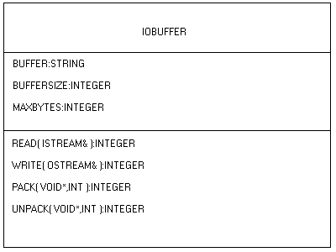

ANALYSIS AND DESIGN OF STUDENT CLASS

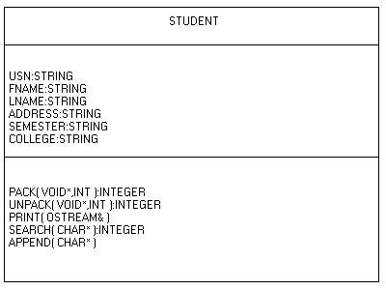

- PART TWO: The design consists of 5 major components:
  - Controller class
  - Record class
  - Stream hierarchy
  - Buffer hierarchy
  - Sequence set

CLASSES USED

Student class: contains methods for pack, unpack, print, get.
IOStream classes: contains methods to handle open streams. Methods include create, open, read, write, rewind, append.
IOBuffer classes: contains methods to handle the memory buffer. Methods include read, write, clear, pack, unpack, print, dread, dwrite.
Directory class: contains methods to manipulate the tree. It knows and hence can be assigned the responsibility.
Bucket class: it contains methods to access the records in a logically sequential order.

TURNING TRIES INTO DIRECTORIES

Rather than representing the trie as tree, we flatten it into an array of contiguous records, forming a directory of hash address and pointers to the corresponding buckets.

The steps involved in it are:
- Make a complete binary tree with all of it leaves at the same level; the new form of tree uses the second address bit.
- Collapse the tree into directory structure.

A
A
0 00

1

0
01

B
B
1 10
1 0

C
C
1 11

CONVERSION OF A TRIE INTO AN ARRAY

SPLITTING AND HANDLING OVERFLOW:

The goal in an extendible hashing is to find a way to increase the address space in response to overflow rather than respond by creating long sequence of overflow records and buckets that have to be searched linearly.
The splitting is done by:
- Splitting bucket to form new bucket.
- Extending the address space to cover these buckets.
- Uses static hashing schemes, as it relies strictly on overflow bucket without extending address space.

BUCKET ‘B’ OVERFLOWS
.

A

A

B
B

D

C

C

DATAFLOW DIAGRAM

PACK
READ INTO OBJECT
PUT INTO BUFFER

WRITE INTO FILE

READ INTO OBJECT
READ FROM FILE
READ INTO BUFFER

UNPACK
WRITE INTO FILE

READ FROM FILE

CODING THE PROJECT

// direct.cpp

#include "D:\NEGI\direct.h"
#include "D:\NEGI\hash.cpp"
#include "D:\NEGI\clear.cpp"
#include "D:\NEGI\mani\functions.h"
#include <strstream.h>

const int MaxKeySize = 12;

Directory::Directory (int maxBucketKeys)
{
Depth = 0; // depth of directory
NumCells = 1; // number of entries, = 2**Depth
BucketAddr = new int [NumCells]; // array of bucket addresses

MaxBucketKeys = maxBucketKeys;
DirectoryBuffer = new LengthFieldBuffer; // default size
DirectoryFile = new BufferFile(*DirectoryBuffer);
CurrentBucket = new Bucket (*this, MaxBucketKeys);
theBucketBuffer = new BucketBuffer (MaxKeySize, MaxBucketKeys);
BucketFile = new BufferFile (*theBucketBuffer);
PrintBucket = new Bucket (*this, MaxBucketKeys);
}

Directory::~Directory ()
{
Close ();
}

void makeNames(char * name, char *& dirName, char *& bktName)
{
ostrstream directoryName;
directoryName<<name<<".dir"<<ends;
dirName = strdup(directoryName.str());
ostrstream bucketName;
bucketName <<name<<".bkt"<<ends;
bktName = strdup(bucketName.str());
}

int Directory::Open (char * name)
{
int result;
char * directoryName, * bucketName;
makeNames(name, directoryName, bucketName);
result = DirectoryFile->Open(directoryName, ios::in|ios::out);
if (!result) return 0;
result = DirectoryFile->Read();
if (result==-1) return 0;
result = Unpack();
if (!result==-1) return 0;
result = BucketFile->Open(bucketName,ios::in|ios::out);
return result;
}

int Directory::Create (char * name)
{
// create two files, clear the directory, create a single bucket
// and add it to the directory and the bucket file
int result;
char * directoryName, * bucketName;
makeNames(name, directoryName, bucketName);
result = DirectoryFile->Create(directoryName, ios::in|ios::out);
if (!result) return 0;
result = BucketFile->Create(bucketName,ios::in|ios::out);
if (!result) return 0;
// store the empty CurrentBucket in the BucketFile and add to Directory
BucketAddr[0] = StoreBucket (CurrentBucket);
return result;
}

int Directory::Close ()
{// write the directory and close. error occurs on buffer overflow
int result;
result = Pack();
if (result==-1) return 0;
DirectoryFile -> Rewind();
result = DirectoryFile->Write();
if (result==-1) return 0;
return DirectoryFile->Close() && BucketFile->Close();
}

int Directory::Insert (char * key, int recAddr)
{
int found = Search (key);
if (found == -1) return CurrentBucket->Insert(key, recAddr);
return 0;// key already in directory
}

int Directory::Remove (char * key)
{// remove the key and return its RecAddr
int bucketAddr = Find(key);
LoadBucket (CurrentBucket, bucketAddr);
return CurrentBucket -> Remove (key);
}

int Directory::Search (char * key)
{// return RecAddr for key, also put current bucket into variable
int bucketAddr = Find(key);
LoadBucket (CurrentBucket, bucketAddr);
return CurrentBucket->Search(key);
}

int Directory::ReSize ()
// double the size of the directory
{
int newSize = 2 * NumCells;
int * newBucketAddr = new int[newSize];
for (int i = 0; i < NumCells; i++)
{
newBucketAddr[2*i] = BucketAddr[i];
newBucketAddr[2*i+1] = BucketAddr[i];
}
delete BucketAddr;
BucketAddr = newBucketAddr;
Depth ++;
NumCells = newSize;
return 1;
}

int Directory :: Collapse()
{
// if collapse is possible reduce size by half
if (Depth == 0) return 0;// only one bucket
// look for buddies that are different, if found return
for (int i=0;i<NumCells;i+=2)
if(BucketAddr[i] != BucketAddr[i+1])
return 0;
int newSize = NumCells / 2;
int * newAddrs = new int [newSize];
for(int j =0; j<newSize;j++)
newAddrs[j] = BucketAddr[j*2];
delete BucketAddr;
BucketAddr = newAddrs;
Depth --;
NumCells = newSize;
return 1;
}

int Directory:: DoubleSize ()
{
// double the size of the directory
int newSize = 2 * NumCells;
int *newBucketAddr = new int[newSize];
for(int i=0;i<NumCells;i++){
newBucketAddr[2*i] = BucketAddr[i];
newBucketAddr[2*i+1] = BucketAddr[i];
}

delete BucketAddr;
BucketAddr = newBucketAddr;
Depth++;
NumCells = newSize;
return 1;
}

int Directory::Reduction ()
{// if collapse is possible, reduce size by half
if (Depth == 0) return 0; // only 1 bucket
// look for buddies that are different, if found return
for (int i = 0; i < NumCells; i += 2)
if (BucketAddr[i] != BucketAddr[i+1]) return 0;
int newSize = NumCells / 2;
int * newAddrs = new int [newSize];
for (int j = 0; j < newSize; j++)
newAddrs[j] = BucketAddr[j*2];
delete BucketAddr;
BucketAddr = newAddrs;
Depth --;
NumCells = newSize;
return 1;
}

int Directory::InsertBucket (int bucketAddr, int first, int last)
{// change cells to refer to this bucket
for (int i = first; i <= last; i++)
BucketAddr[i] = bucketAddr;
return 1;
}

int Directory::RemoveBucket (int bucketIndex, int bucketDepth)
{// implementation left as exercise
// set all cells for this bucket to its buddy bucket
int fillBits = Depth-bucketDepth; // number of bits to fill
int buddyIndex = bucketIndex ^ (1<<(fillBits-1)); // flip low bit
int newBucketAddr = BucketAddr[buddyIndex];
int lowIndex = bucketIndex >> fillBits << fillBits; // zero low bits
int highIndex = lowIndex + (1<<fillBits) - 1; // set low bits to 1
for (int i = lowIndex; i <= highIndex; i++)
BucketAddr[i] = newBucketAddr;
return 0;
}

int Directory::Find (char * key)
// return BucketAddr for key
{
return BucketAddr[MakeAddress (key, Depth)];
}

int Directory::Pack () const
{// pack the buffer and return the number of bytes packed
int result, packsize;
DirectoryBuffer -> Clear();
packsize = DirectoryBuffer -> Pack (&Depth, sizeof(int));
if (packsize == -1) return -1;
for (int i = 0; i<NumCells; i++)
{
result = DirectoryBuffer -> Pack (&BucketAddr[i], sizeof(int));
if (result == -1) return -1;
packsize += result;
}
return packsize;
}

int Directory::Unpack ()
{
int result;
result = DirectoryBuffer -> Unpack (&Depth, sizeof(int));
if (result == -1) return -1;
NumCells = 1 << Depth;
if (BucketAddr != 0) delete BucketAddr;
BucketAddr = new int[NumCells];
for (int i = 0; i<NumCells; i++)
{
result = DirectoryBuffer -> Unpack (&BucketAddr[i], sizeof(int));
if (result == -1) return -1;
}
return 0;
}

int Directory::StoreBucket (Bucket * bucket)
{// update or append the bucket to the bucket file
int result;
result = theBucketBuffer -> Pack (* bucket);
if (result == -1) return -1;
int addr = bucket->BucketAddr;
if (addr != 0) return BucketFile->Write (addr);
addr = BucketFile -> Append ();
bucket -> BucketAddr = addr;
return addr;
}

int Directory::LoadBucket(Bucket * bucket, int bucketAddr)
{// read bucket from file, and set BucketAddr field
int result;
result = BucketFile -> Read (bucketAddr);
if (result == -1) return 0;
result = theBucketBuffer -> Unpack (*bucket);
if (result == -1) return 0;
bucket->BucketAddr = bucketAddr;
return 1;
}
/*
ostream & Directory::Print (ostream & stream)
{
clearScr();
gotoxy(4,6);
stream <<"Directory Depth "<<Depth<<endl;
gotoxy(4,7);
stream <<"Directory Size "<<NumCells<<endl;
gotoxy(30,50);
for (int i = 0; i<NumCells; i++)
{

stream <<"Bucket "<<BucketAddr[i]<<" addr "<<(void *) i<<endl;
LoadBucket (PrintBucket, BucketAddr[i]);

PrintBucket->Print(stream);
getch();
clearScr();
}
gotoxy(4,10);
stream <<"End of directory"<<endl;
return stream;
}
*/
int Directory::getdepth()
{
return Depth;
}

void Directory::Print (void)
{
clearScr();
int tcells=0;
int count=1;
int drow=50;
int col=110;
int x1,y1;
int x=10;int y=60;

setcolor(RED);
settextstyle(0,0,1);

outtextxy(10,y,"DIRECTORY DEPTH : ");
x=x+textwidth("DIRECTORY DEPTH : ");
y=60;
gprintf(&x,&y,"%d",Depth);
x=10;y=70;
gprintf(&x,&y,"DIRECTORY SIZE (2^depth) : ");
x=x+textwidth("DIRECTORY SIZE : ");
y=70;
gprintf(&x,&y,"%d",NumCells);

for (int i = 0; i<NumCells; i++)
{

disp: if(tcells<32)
{

//write direc addr
setcolor(YELLOW);
x=10;
y=95;
outtextxy(x,y,"DIR");
//write directory contents
x=70;
outtextxy(x,y,"DIRECTORY");
x=160;
outtextxy(x,y,"BUCKET ADDR");

x=260;
outtextxy(x,y,"KEY");
x=330;
outtextxy(x,y,"ADDR");

x=380;
outtextxy(x,y,"KEY");
x=450;
outtextxy(x,y,"ADDR");

x=500;
outtextxy(x,y,"KEY");
x=570;
outtextxy(x,y,"ADDR");

settextstyle(0,0,1);

//draw directory

setcolor(DARKGRAY);
rectangle(drow,col,drow+100,col+10);
setcolor(BROWN);
//draw directory address
x1=10;
y1=col+1;
gprintf(&x1,&y1,"%p",i);

//print directory contents
x1=drow+40;
y1=col+1;
setcolor(WHITE);
gprintf(&x1,&y1,"%d",BucketAddr[i]);

if(BucketAddr[i]!=BucketAddr[i+1])
{
//draw buckets
setcolor(DARKGRAY);
rectangle(250,col,370,col+10);
rectangle(330,col,370,col+10);
rectangle(370,col,490,col+10);
rectangle(450,col,490,col+10);
rectangle (490,col,610,col+10);
rectangle (570,col,610,col+10);
setcolor(9);
x1=210;
y1=col+1;
gprintf(&x1,&y1,"%d",BucketAddr[i]);
count++;
//DRAW ARROWS
setcolor(CYAN);
line(155,col+5,205,col+5);
line(205,col+5,201,col+1);
line(205,col+5,201,col+9);
//LOAD THE BUCKET
LoadBucket (PrintBucket, BucketAddr[i]);
int mkeys=PrintBucket->retMaxKeys();
int nkeys=PrintBucket->retNumKeys();
setcolor(6);
x1=240;
y1=col+1;
gprintf(&x1,&y1,"%d",nkeys);
settextstyle(2,0,0);

int x2=252;
int y2=col;
for(int j=0;j<nkeys;j++)
{
if(j==0)
{
x2=252;
}
if(j==1)
{
x2=372;
}
if(j==2)
{
x2=492;
}
setcolor(CYAN);
settextstyle(2,0,4);
char* key=PrintBucket->retKey(j);
int raddr=PrintBucket->retRecAddr(j);
gprintf(&x2,&y2,"%s",key);
x2=x2+82;
y2=col;
gprintf(&x2,&y2,"%d",raddr);
y2=col;

}
settextstyle(0,0,0);

}

x1=15;
y1=440;
setcolor(RED);
outtextxy(x1,y1,"CURRENTLY DISPLAYING DIRECTORY CELLS ( ");
x1=15+textwidth("CURRENTLY DISPLAYING DIRECTORY CELLS ( ");
y1=440;
gprintf(&x1,&y1,"%d",tcells+1);
x1=15+textwidth("CURRENTLY DISPLAYING DIRECTORY CELLS ( ");
y1=440;
outtextxy(x1,y1," TO ");
x1=15+textwidth("CURRENTLY DISPLAYING DIRECTORY CELLS ( ")+textwidth(" TO ");
y1=440;
gprintf(&x1,&y1,"%d",NumCells);

x1=15+textwidth("CURRENTLY DISPLAYING DIRECTORY CELLS ( ")+textwidth(" TO ");
y1=440;
outtextxy(x1,y1," ) FROM A TOTAL NUMBER OF ");
x1=15+textwidth("CURRENTLY DISPLAYING DIRECTORY CELLS ( ")+textwidth(" TO ")+textwidth(" ) FROM A TOTAL NUMBER OF ");
y1=440;
gprintf(&x1,&y1,"%d ",NumCells);

}
else
{
i=0;
DrawStatusBar("HELP","DATA FILE D:\\NEGI\\HASH.DIR STILL HAS DATA ! PRESS ANY KEY");

int x1=15;
int y1=440;
setcolor(RED);
outtextxy(x1,y1,"CURRENTLY DISPLAYING DIRECTORY CELLS ( ");
x1=15+textwidth("CURRENTLY DISPLAYING DIRECTORY CELLS ( ");
y1=440;
gprintf(&x1,&y1,"%d",tcells);
x1=15+textwidth("CURRENTLY DISPLAYING DIRECTORY CELLS ( ");
y1=440;
outtextxy(x1,y1," TO ");
x1=15+textwidth("CURRENTLY DISPLAYING DIRECTORY CELLS ( ")+textwidth(" TO ");
y1=440;
gprintf(&x1,&y1,"%d",NumCells-1);

x1=15+textwidth("CURRENTLY DISPLAYING DIRECTORY CELLS ( ")+textwidth(" TO ");
y1=440;
outtextxy(x1,y1," ) FROM A TOTAL NUMBER OF ");
x1=15+textwidth("CURRENTLY DISPLAYING DIRECTORY CELLS ( ")+textwidth(" TO ")+textwidth(" ) FROM A TOTAL NUMBER OF ");
y1=440;
gprintf(&x1,&y1,"%d ",NumCells);

tcells+=20;
getche();
clearScr();
goto disp;
}
col=col+10;
}

setcolor(RED);
settextstyle(0,0,0);
x=10;y=80;
gprintf(&x,&y,"TOTAL NUMBER OF BUCKETS : ");
x=x+textwidth("DIRECTORY SIZE : ");
y=80;
gprintf(&x,&y,"%d",count-1);
DrawStatusBar("HELP","PRESS ANY KEY TO CONTINUE");

getche();
clearScr();
}

float Directory::Space_util(char* myfile)
{
fstream file;
file.open(myfile,ios::in);

float count=1;

for(int i=0;i<NumCells-1;i++)
{
if(BucketAddr[i]==BucketAddr[i+1])
continue;
else
count++;
}

return count;
}

int Directory::getnumcells()
{
return NumCells;
}
Bucket::Bucket (Directory & dir, int maxKeys) // constructor
:TextIndex (maxKeys), Dir (dir)
{
BucketAddr = 0;
Depth = 0;
}

int Bucket::Insert (char * key, int recAddr)
{
if (NumKeys < MaxKeys)
{
int result = TextIndex::Insert (key, recAddr);
Dir.StoreBucket (this);
return result;
}
else
{
Split ();
return Dir.Insert (key, recAddr);
}
}

int Bucket::Remove (char * key)
{// remove the key, return its RecAddr
int result = TextIndex::Remove (key);
if (!result) return 0; // key not in bucket
TryCombine (); // attempt to combine with buddy
// make the changes permanent
Dir.StoreBucket(this);
return 1;
}

Bucket * Bucket::Split ()
{
int newStart, newEnd;
if (Depth == Dir.Depth)// no room to split this bucket
Dir.DoubleSize();
Bucket * newBucket = new Bucket (Dir, MaxKeys);
Dir.StoreBucket (newBucket);
NewRange (newStart, newEnd);
Dir.InsertBucket(newBucket->BucketAddr, newStart, newEnd);
Depth ++;
newBucket->Depth = Depth;
Redistribute (*newBucket);
Dir.StoreBucket (this);
Dir.StoreBucket (newBucket);
return newBucket;
}

int Bucket::FindBuddy ()
{// find the directory address of the bucket that is paired with this
if (Dir.Depth == 0) return -1; // no buddy, empty directory
// unless bucket depth == directory depth, there is no single
// bucket to pair with
if (Depth < Dir.Depth) return -1;
int sharedAddress = MakeAddress(Keys[0], Depth); // address of any key
return sharedAddress ^ 1; // exclusive or with low bit
}

int Bucket::TryCombine ()
{// called after insert to combine buddies, if possible
int result;
int buddyIndex = FindBuddy ();
if (buddyIndex == -1) return 0;// no combination possible
// load buddy bucket into memory
int buddyAddr = Dir.BucketAddr[buddyIndex];
Bucket * buddyBucket = new Bucket (Dir, MaxKeys);
Dir . LoadBucket (buddyBucket, buddyAddr);
// if the sum of the sizes of the buckets is too big, return
if (NumKeys + buddyBucket->NumKeys > MaxKeys) return 0;
Combine (buddyBucket, buddyIndex);// collapse the 2 buckets
result = Dir.Collapse ();
if (result) TryCombine(); //if collapse, may be able to combine
return 1;
}

int Bucket::Combine (Bucket * buddy, int buddyIndex)
{// collapse this and buddy into a single bucket
int result;
// move keys from buddy to this
for (int i = 0; i < buddy->NumKeys; i++)
{// insert the key of the buddy into this
result = Insert (buddy->Keys[i],buddy->RecAddrs[i]);
if (!result) return 0;
}
Depth --;// reduce the depth of the bucket
Dir . RemoveBucket (buddyIndex, Depth);
return 1;
}

int Bucket::NewRange (int & newStart, int & newEnd)
{// make a range for the new split bucket
int sharedAddr = MakeAddress(Keys[0], Depth);
int bitsToFill = Dir.Depth - (Depth + 1);
newStart = (sharedAddr << 1) | 1;
newEnd = newStart;
for (int j = 0; j < bitsToFill; j++)
{
newStart = newStart << 1;
newEnd = (newEnd << 1) | 1;
}
return 1;
}

int Bucket::Redistribute (Bucket & newBucket)
{
// check each key in this bucket
for (int i = NumKeys - 1; i >= 0; i--)
{
int bucketAddr = Dir.Find (Keys[i]); // look up the bucket
if (bucketAddr != BucketAddr)// key belongs in the new bucket
{
newBucket.TextIndex::Insert (Keys[i], RecAddrs[i]);
TextIndex::Remove (Keys[i]); // delete key from this bucket
}
}
Return

TESTING INCLUDING SNAPSHOTS

Software testing is an important element of software quality of specification design and coding. In testing, the engineer creates a series of test cases that are intended to stretch the software to its limit.

- OBJECTIVES OF TESTING:

  - It is a process of executing a program with the intend of finding an error

  - A good test case is one that can find an undiscovered error.

  - A successful test is one that uncovers an uncovered error.

- TYPES OF TESTING:

  - System Testing: After the system has been satisfactorily coded, the product must be undergoing for a testing process.
  - Unit /component Testing: The different modules are tested independently, the base module is tested first and then all modules are tested eventually with a wide range of input values.
  - Integration Testing: The module of the system has been first taken and according to the linkage priority each module is integrated into the system. This is to check whether the system responds after the modules have been integrated together into a single unit.

TESTING INFORMATION-FLOW

EVALUATION

S/W CONFIG

ERRORS
TEST RESULT

TESTING DEBUG

CORRECTIONS

RELIABILITY MODEL

EXPECTED RESULT

PREDICATE RELIABILITY

TEST COFIG

SNAPSHOTS

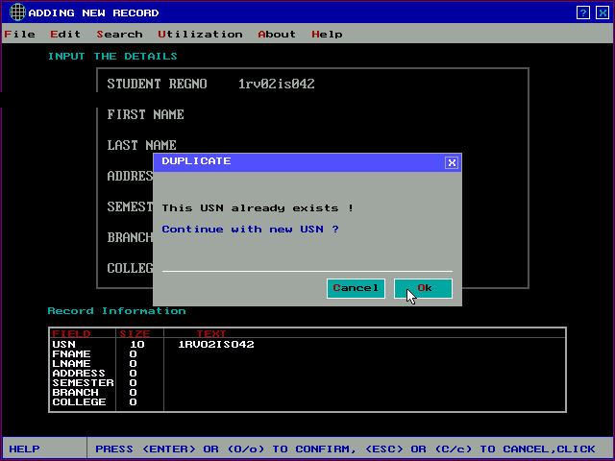

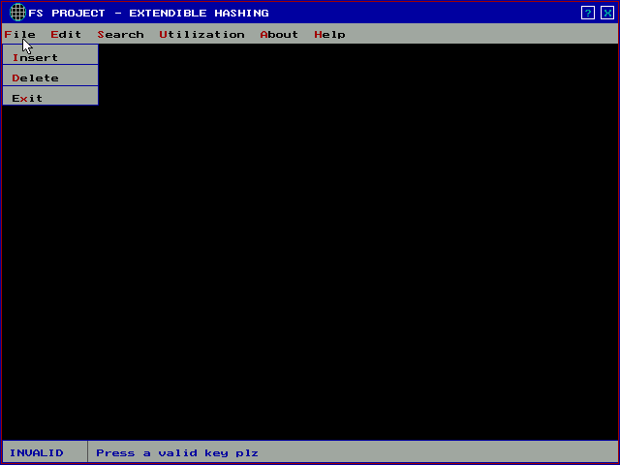
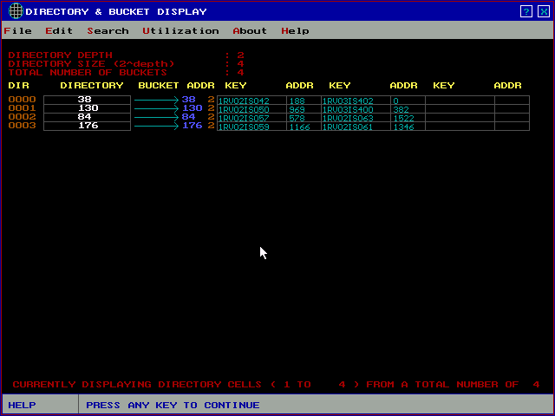

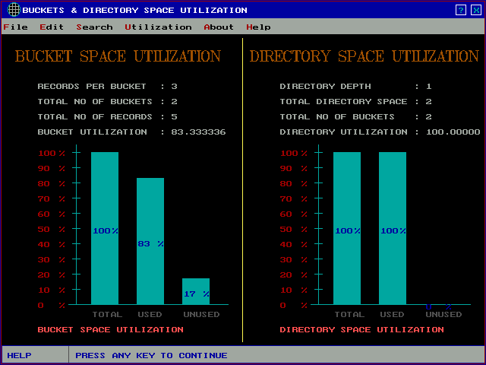

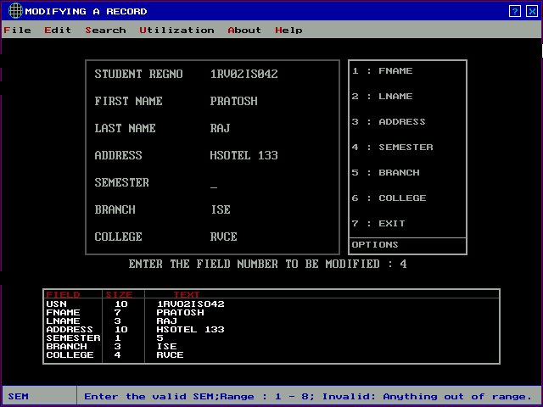

CONCLUSION

The project has successfully encapsulated the idea of an OBJECT ORIENTED ANALYSIS AND DESIGN TO FILE STRUCTURES.
It has also achieved the following as a mark of the OOP approach:

- Has suitably incorporated the concept of file buffering to store and retrieve the objects from the file.

- Has included different types of record structures like delimited-fields and delimited records, variable length records.

- Gives a proper demonstration of c++ file streams to handle file objects.

- Gives a clear illustration of the principles of economy of expressions and separation of concerns in buffer class hierarchy and other classes.

ADVANTAGES OF EXTENDIBLE HASHING:

- Allows the address space of hashing to grow and shrink along with file.
- Provides hashed access without the need for overflow handling.
- Trie is used for extending the use of hashed value.
- Access performance for extendible hashing is a single seek.
- Space utilization for bucket is approximately 69%.
- Greater space utilization and seek performance.
- Using deferred splitting; it is possible to increase space utilization for any of the hashing schemes to 80%

DISADVANTAGES OF EXTENDIBLE HASHING:

  - Make use of more bit of hashed value to cover more address space.
  - Filling all the leaves of the trie until there is a perfect tree.
  - Doubling the address space due to splitting of bucket to accommodate the use of the new bit.
  - Records can be combined for two bucket only if they are buddy bucket.

FUTURE ENHANCEMENTS

An enormous amount of enhancements are possible in the project presented in this report. We have just presented a bare bone structure of extensible hashing; however with the addition of new ideas and alteration of already existing ones we can make the project stronger and more efficient.

Some of the possible modifications are as follows:

- Instead of using a student class we can alter the project to include generic classes that can accept a wide variety of data types and parameters.

- Another class says, buffer file can be included, given that it contains a handle to the base class of the buffer class hierarchy i.e.IOBuffer and handle to the file for simultaneous manipulation of the buffer and the file to support more pure form of the OBJECT OREIENTED APPROACH.

  - The extendible hashing works well with everything implemented, but the disk utilization is not up to the mark.

  - In order to increase the disk utilization we can opt for the following
        - Use variable length record
        - Do not use delete marker, instead delete the record itself.

BIBLIOGRAPHY

A great deal of material has been accessed from both books and the Internet for the successful accomplishment of the project.
We are grateful to the authors of these materials for the invaluable help rendered for the project to be a reality.

- FILE STRUCTURES

  - MICHAEL J. FOLK
  - BILL ZOELLICK
  - GREG RICCARDI

- OBJECT ORIENTED PROGRAMMING IN C++

  - E. BALAGURUSWAMY

- LET US C

  - YASHWANT KANETKAR

- GRAPHICS IN C

  - YASHWANT KANETKAR

- C++ COMPLETE REFERENCE

  - AUTHORS (S)

HELP FROM THE INTERNET (WEBSITES)

- www.aw.com/titles

- www.alphaworks.ibm.com

